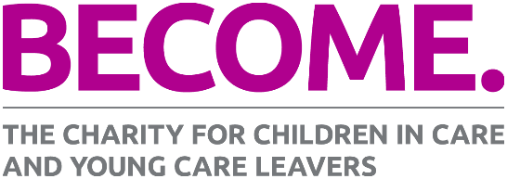

Making the most of Care Day 2018
16 February 2018

Care Day is a joint initiative between children’s charities across the whole of the UK and Ireland, under the 5 Nations, 1 Voice alliance. The charities in the alliance are: Become in England, EPIC in Ireland, VOYPIC in Northern Ireland, Who Cares? Scotland, and Voices from Care in Wales.

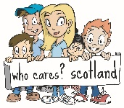

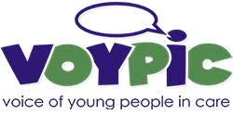

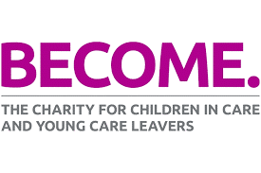
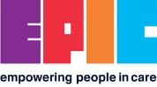

Care Day 2018 will celebrate the rights of care-experienced children and young people across the UK, Ireland and beyond. The 5 Nations, 1 Voice alliance invites every care-experienced child, young person or adult to join in this day of celebration. It also invites every corporate parent, elected representatives, third sector organisations and other supportive organisations and individuals to join in this celebration.
Every care-experienced person deserves to have a childhood in which they thrive and are celebrated for every part of who they are and what they achieve. It’s their right – and this Care Day, we will be shouting about that from the rooftops across the UK and Ireland.
By taking part in Care Day, you’re showing children and young people in care, and care leavers, that you are supporting them – and taking their rights seriously.

This guide will help you, and your organisation, get involved in Care Day 2018 and let you know how you can support Become throughout the year.
How you and your organisation can get involved in Care Day 2018

Use the #CareDay18 placard

There are two Care Day placards available for download. One for children and young people in care, and care leavers, and one for professionals who work with them.

Download the relevant placard to you, print it off, write your message, and share it on social media using the hashtag #CareDay18.

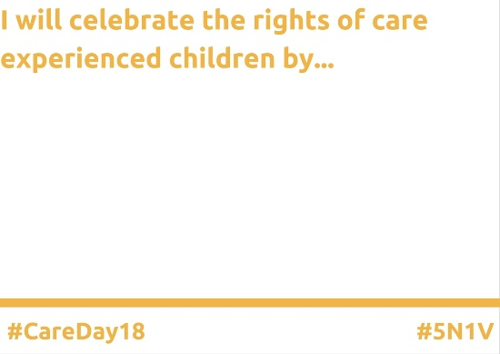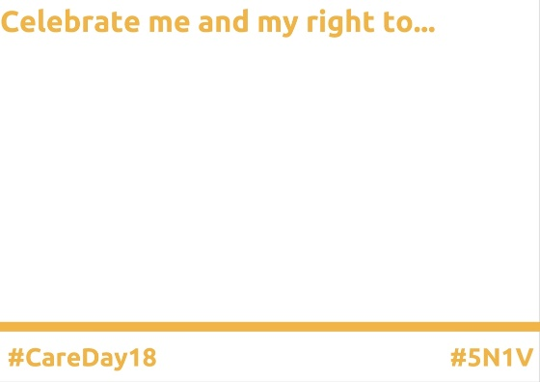

Using placards on social media are an exciting way to share your individual message of support for care-experienced children and young people.

In previous years, the Care Day placard has been used by politicians, directors of children’s services, care-experienced young people, celebrities, sports stars, and many more. Join them by adding your voice to #CareDay18.

Write a blog

Not everyone will know what you think, or what your organisation is doing – so tell them!

A blog from a social worker, a personal advisor, even your director of service, would be enlightening to the readers and help them understand how you are working to defend the rights of the children and young people that you care for.

At Become, we aim for our blogs to be between 500-750 words, and we put them on the news page of our website alongside a picture that illustrates what we are discussing.

This is an example of a blog that Become have published telling people about Propel.org.uk – our website aimed at supporting care-experienced young people into further and higher education: http://www.becomecharity.org.uk/news-and-opinion/going-to-uni-this-year-booked-on-to-an-open-day-yet/

Use the Twibbon

You can use the #CareDay18 Twibbon on your Facebook and Twitter pages. A Twibbon is simple to use, and puts a message over your profile picture which shows that you are supporting the campaign. When Care Day finishes, all you have to do is to upload your picture again to remove the Twibbon.

Get the Twibbon here: https://twibbon.com/Support/care-day-2018

Write to the children in your care

Whether you are a corporate parent, a foster carer, working to provide a valuable service to care-experienced children – why not write to them to reaffirm your commitment to them throughout 2018?

We all work tirelessly to provide positive childhoods for those who can’t live at home. A letter to a child in care is a simple gesture, but it can be a very effective one, telling them that they’re cared for and have people who believe in them.

Organise an event for the children in your care

Holding an event to celebrate the children in your care can be an excellent way to strengthen your local care community. This could range from an event at your office, to a trip to the local bowling alley. Engaging directly with the children in your care to celebrate Care Day will make them feel valued, and ensure they know that people around them believe they can build a positive life for themselves.

Support Become to help us support the children in your care all year round

Become is the leading charity for children and young people in care, and young care leavers in England. We fight tirelessly, like you, all year round to make sure that care-experienced children and young people have a voice. We lead on national policy and campaigning, and we have made a real impact over our 25 years as a charity. However, to continue our work, we need your support.

Download our Become a Baking Hero pack and hold a bake sale in your office for Become to help us ensure that we can keep Care Day, and our work, going for as long as we are needed.

